Cup Dispenser:

The Cup Dispenser Mechanism is used to separate single cup at a time from stack of cups. This is an important mechanism for reliable working of complete system. The Mechanism has to separate one cup when required and time and power required for working should be minimum. We considered different mechanisms for the task and came across a very suitable mechanism for the application in U.S Patent [] by Graffenburger. The mechanism described has minimum number of parts, the machining accuracy required is moderate and also the power and time requirement for it is less and suitable for application.

The mechanism uses the taper shape of paper cups and the thick paper fold at rim of the cup for separating and supporting purpose. The mechanism also uses the fact that there is certain gap in folded rims of stacked cups due to taper shape. The bottommost cup of the stack is initially separated from rest of the stack using a pointed flange moving parallel to rim. Once there is separation of bottom cup from the stack the cup is transferred to a U shaped opening having diameter more than outer diameter of cup. This makes the cup fall down in the opening and completely separating from the stack while the rest of stack is supported on the upper portion of the flange having a support of diameter less than outer diameter but more than inner rim diameter of cup.

The most important part of the mechanism is separator having separating flange and opening which has somewhat complicated shape and hence can be made using rapid prototyping 3d printer. The other parts of the mechanism include slide for motion of separator and actuator like Servo motor for precise motion of the separator and also the linkages to connect separator to the actuator.

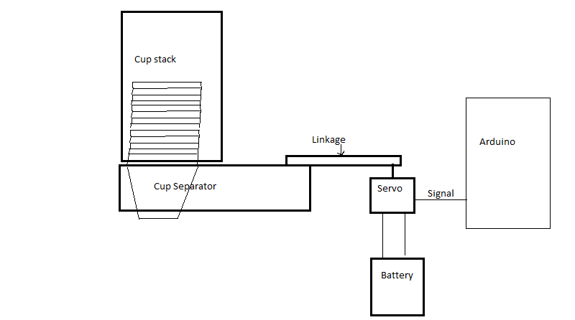

**Cup Dispenser Block Diagram**